
Company
Logotype

Cone Beam Computed Tomography- Report



Porur Dental X-rays & CBCT

Patient Name : Mr. Bargavan | Date of Report : 16.03.2024
Age/ Gender : 13 years/ Male | Region of Interest : CBCT Full Skull
Referring doctor: Dr. A. Dany | Indication : Impacted teeth
Clinical Notes: Nil
PATIENT INFORMATION

CBCT Full Skull provided
CBCT – IMAGE DETAILS

RADIOGRAPHIC INTERPRETATION

- No of teeth present in the maxillary and mandibular alveolar ridge: 34
- Deciduous teeth: 53, 65
- Developing crowns: 18, 28, 38, 48.
- The tooth 13 appears to be within the alveolar bone, distally tipped and lies above the periapical aspect of the deciduous tooth: 53 and in proximity to the medial wall of right maxillary sinus.
- The teeth 33, 43 appears to be within the alveolar bone between 32, 34 and 42, 44 respectively, below the level of alveolar bone.
- Complete hyperdense opacification of the left maxillary sinus and partial opacification of the right maxillary sinus is evident.

RADIOGRAPHIC IMPRESSION


- Permanent successor : 13 above retained deciduous: 53.
- Deciduous teeth: 53, 65
- Bilateral maxillary sinusitis.

IMAGES FOR REFERENCE

RECONSTRUCTED PANORAMA VIEW
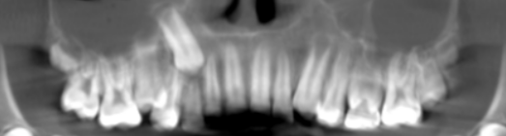
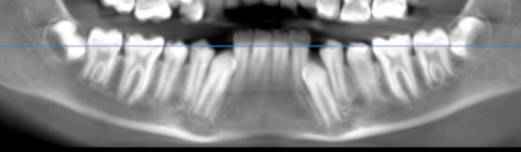
CROSS- SECTIONAL IMAGES
13 REGION | 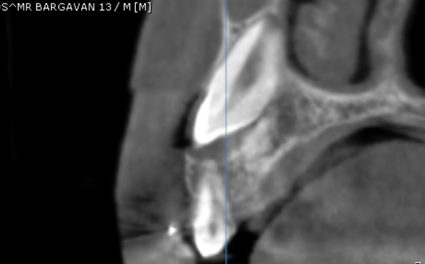

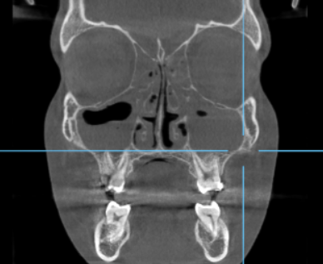
Partial opacification of right maxillary sinus
Complete opacification of left maxillary sinus

3-DIMENSIONAL VIEW

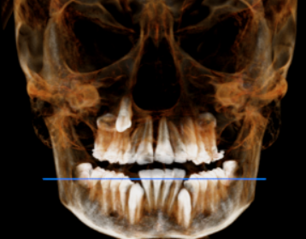

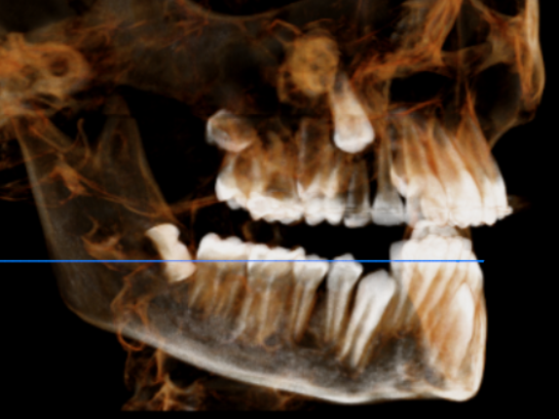

**** End of report ****

